Math 1 Name_________________________________

**5-1 Translations Practice** Date__________

**1.** **Graph each figure and the image under the given translation. Name the new coordinates.**

**a.**  with vertices L(-3, -1),

I(-1, 4), and P(2, 2) under the translation .

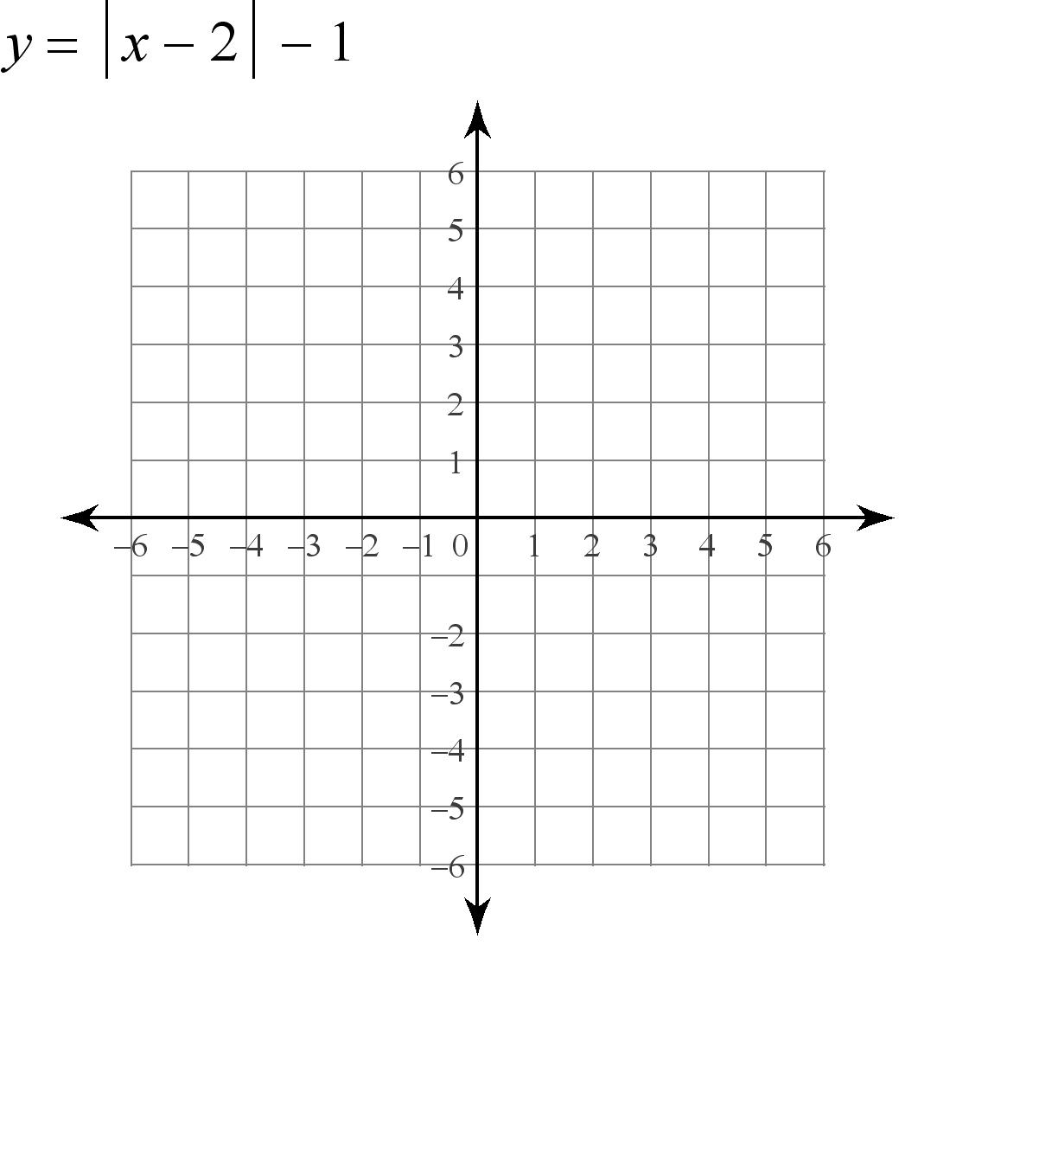

**b.** Quadrilateral DUCK with vertices D(2,2), U(4, 1), C(3, -2), and K(0,-1) under the translation .

**c.**  with vertices R(-4, -1), S(-1, 3), and T(-1, 1)under the translation 

L’_____

I’_____

P’_____

D’_____

U’_____

C’_____

K’_____

R’_____

S’_____

T’_____

**d.** Quadrilateral BAND with vertices B(-3, -3), A(2, -3), N(5, 1), and D(1, 1) under the translation .

**e.** Pentagon MOUSE with vertices M(-1, -2), O(2, -1), U(5, -2), S(4, -4), and E(1, -4) under the translation .

**f.** Quadrilateral MATH with vertices M(4, 1), A(2, 4), T(0,6), and H(1,2) under the translation .



B’_____

A’_____

N’_____

D’_____

M’_____

O’_____

U’_____

S’_____

E’_____

M’_____

A’_____

T’_____

H’_____